Emerson Drapac

IT 440

DB Phase 4 12 Queries

1. List all employees (employee number, first and last names, age,

and commission details) from Illinois.

SELECT e.employee_id, e.employee.first_name, e.employee.last_name,e.employee.age() AGE, e.employee.comission COMMISSION, a.state

FROM O_employee e, TABLE (address) a

WHERE a.state = 'IL';

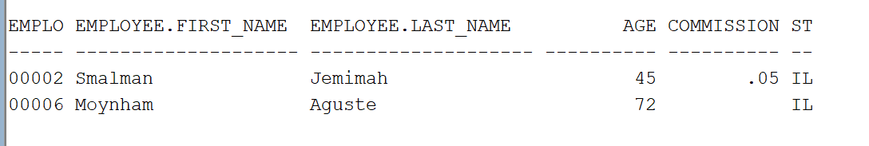

2. Find number of employees and their total

commissions.

SELECT COUNT(e.employee_id) TOTAL_EMPLOYEES, SUM(e.employee.commission) TOTAL_COMMISSION

FROM O_employee e;

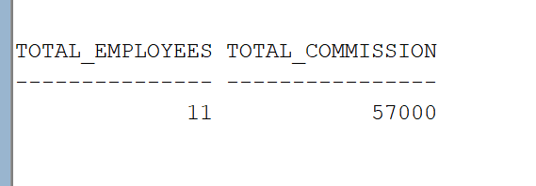

3. List all employees whose commission is greater than the average

commission, and show by how much.

SELECT e.employee_id EMP_NO, e.employee.first_name FNAME,

e.employee.last_name LNAME,e.employee.commission COMMISSION,

s.AVGS AVG_COM,

(e.employee.commission - s.AVGS) DIFFERENCE

FROM

(select avg(e.employee.commission) AVGS

from o_employee e) s,

o_employee e

WHERE e.employee.commission > s.AVGS;

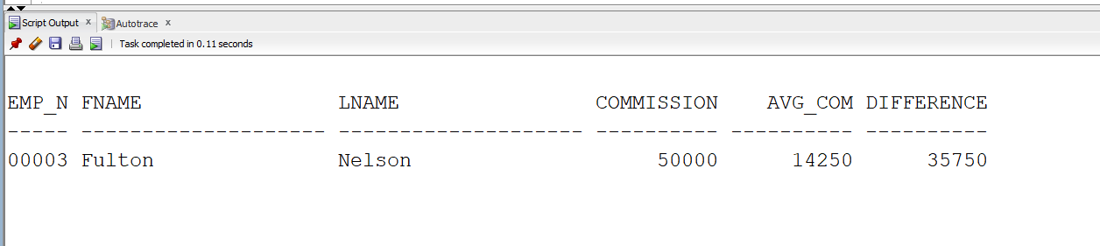

4. Find employees whose commission is larger than commission of

the employee with ID '00002'.

SELECT e.employee_id EMP_NO, e.employee.first_name FNAME,

e.employee.last_name LNAME,e.employee.commission COMMISSION

FROM o_employee e

WHERE e.employee_id NOT LIKE '00002'

AND e.employee.commission IS NOT NULL;

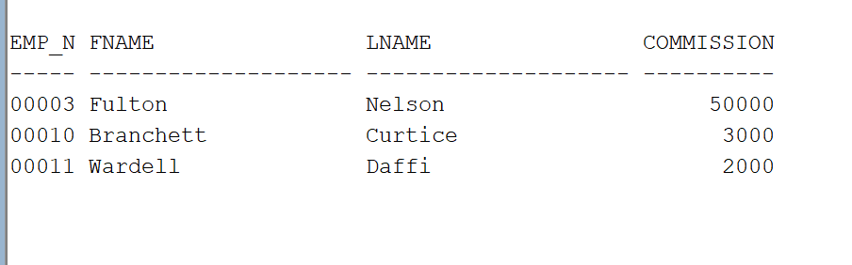

5. List numbers and first names of employee

who deal with the customers and the customers they deal with.

SELECT distinct e.employee_id , o.customer_id, e.employee.first_name FNAME,

e.employee.last_name LNAME, c.customer.first_name,

c.customer.last_name

FROM o_employee e

JOIN customer_order o on o.employee_id = e.employee_id

JOIN o_CUSTOMER c on c.customer_id = o.customer_id;

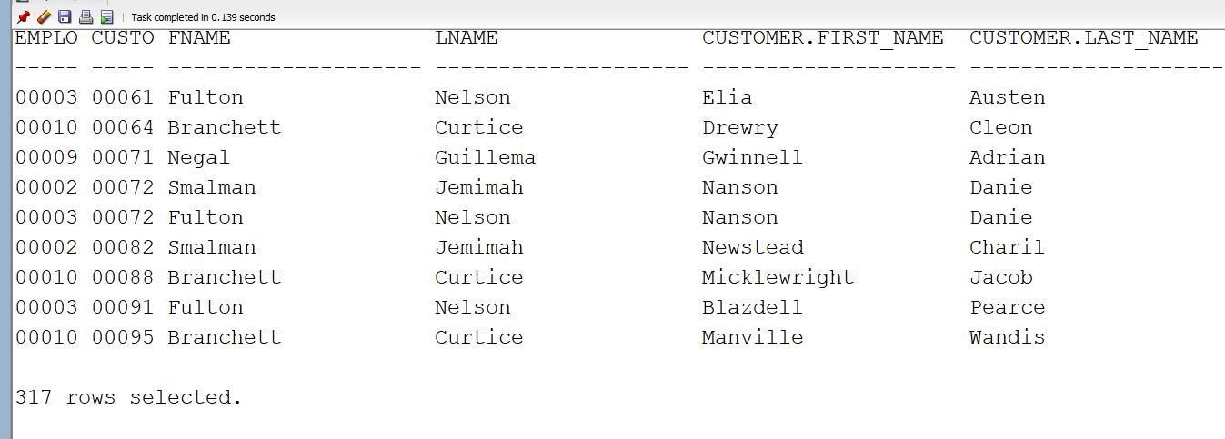

6. Find number of customers handled by each employee member.

SELECT e.employee_id , count(o.customer_id) CUST_COUNT, e.employee.first_name FNAME,

e.employee.last_name LNAME

FROM o_employee e

JOIN customer_order o on o.employee_id = e.employee_id

JOIN o_CUSTOMER c on c.customer_id = o.customer_id

GROUP BY e.employee_id,e.employee.first_name,

e.employee.last_name;

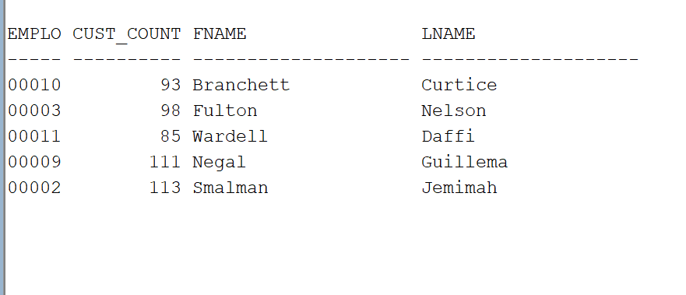

7. List all employees who are either dealing with customers or

not, and also their customer names.

SELECT e.employee_id , count(o.customer_id) CUST_COUNT, e.employee.first_name FNAME,

e.employee.last_name LNAME, c.customer.first_name

FROM o_employee e

left JOIN customer_order o on o.employee_id = e.employee_id

left JOIN o_CUSTOMER c on c.customer_id = o.customer_id

GROUP BY e.employee_id,e.employee.first_name,

e.employee.last_name, c.customer.first_name;

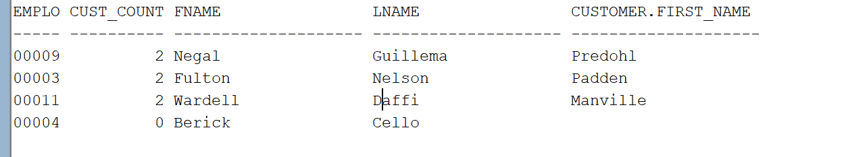

8. List employees have helped customers fulfill orders and which employees don't have orders as well as order count

SELECT e.employee_id , count(o.customer_id) ORDER_COUNT, e.employee.first_name FNAME,

e.employee.last_name LNAME

FROM o_employee e

LEFT JOIN customer_order o on o.employee_id = e.employee_id

GROUP BY e.employee_id,e.employee.first_name,

e.employee.last_name;

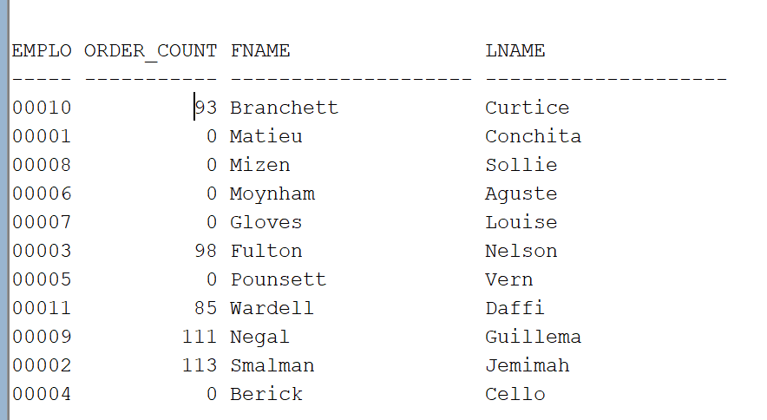

9. List employees have helped customers fulfill orders and which employees don't have orders as well as order count and the total commission generated by each employee

SELECT e.employee_id , count(o.customer_id) ORDER_COUNT, e.employee.first_name FNAME,

e.employee.last_name LNAME, e.employee.commission

FROM o_employee e

LEFT JOIN customer_order o on o.employee_id = e.employee_id

GROUP BY e.employee_id,e.employee.first_name,

e.employee.last_name, e.employee.commission;

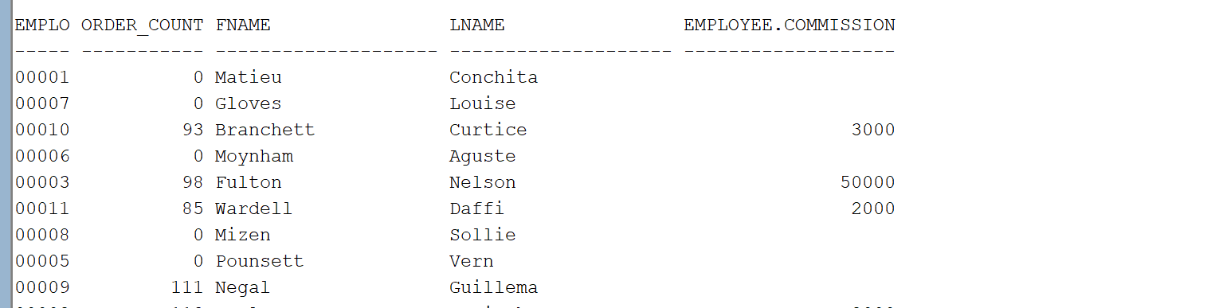

10. List all cities where there is either an employee in that city

or there is a customer from that city.

SELECT e.city

from o_employee e, TABLE(ADDRESS) e

UNION

SELECT c.city

FROM o_customer c, TABLE(ADDRESS) c;

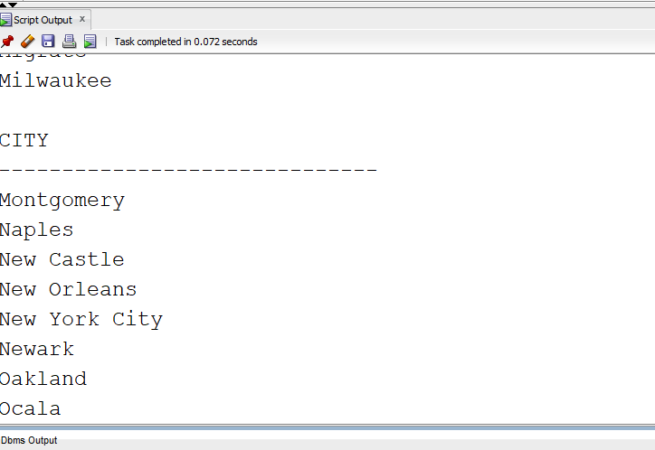

101 rows selected

11. Show the top three customers according to their total sales.

With qty1 as

(

select CO.ORDER_ID, SUM(P.PRICE) SUMS, OC.CUSTOMER_ID

from PAINTING_ORDER PO

JOIN PAINTING P on PO.PAINTING_ID = P.PAINTING_ID

JOIN CUSTOMER_ORDER CO on PO.ORDER_ID = CO.ORDER_ID

JOIN O_CUSTOMER OC on CO.CUSTOMER_ID = OC.CUSTOMER_ID

group by CO.ORDER_ID, OC.CUSTOMER_ID

)

SELECT t.rank,t.sums,t.cust_id

FROM

(

SELECT RANK() over (order by SUM(qty1.SUMS) desc) as RANK,

SUM(qty1.SUMS) SUMS , qty1.CUSTOMER_ID CUST_ID

FROM qty1

GROUP BY qty1.CUSTOMER_ID) t

WHERE t.RANK <=3;

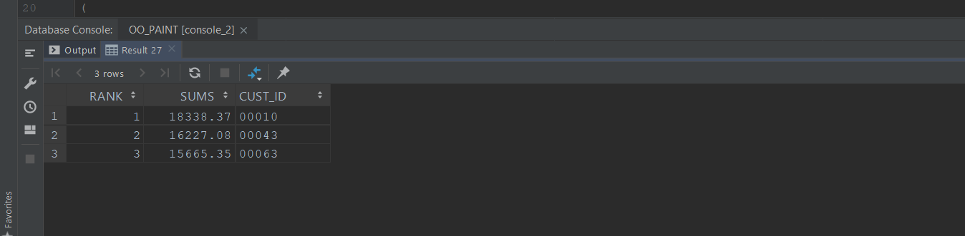

12. Show employee Id, employee full name (last, first), city,

state, and their position. Your result should be sorted

according to Sales Manager first, Sales second, Finance third,

and the others as fourth. (Hint: uses the DECODE to order the

result)

select e.employee_id EMPLOYEE_NO, e.employee.first_name FNAME, e.employee.last_name LNAME,

a.city CITY, a.state ST, e.employee.position POSITION

from o_employee e, TABLE (address) a

order by Decode(e.employee.position, 'Sales Manager', 1,

'Sales', 2,

'Finance', 3,

4), e.employee_id;

